**20BCE1837**

**EXP 4: JavaScript exercises**

**AIM:**.

**PROCEDURE:**

**CODE:**

**1.  Write a JavaScript program to calculate multiplication and division of two numbers. Get inputs from user.**

<html>

<body>

<form>

1st Number : <input type="text" id="firstNumber">

<br>

2nd Number: <input type="text" id="secondNumber">

<br>

<input type="button" onClick="multiplyBy()" Value="Multiply">

<br>

<input type="button" onClick="divideby()" value="divide">

<br>

</form>

<p>

The Result is :

<br>

<span id = "result">

</span>

</p>

<script>

function multiplyBy()

{num1 = document.getElementById("firstNumber").value;

num2 = document.getElementById("secondNumber").value;

document.getElementById("result").innerHTML = num1 * num2;}

function divideby()

{num1 = document.getElementById("firstNumber").value;

num2 = document.getElementById("secondNumber").value;

document.getElementById("result").innerHTML = num1/num2;}

</script>

</body>

</html>

**2. Write a JavaScript program that accept two integers and display the larger**

<html>

<body>

<script>

var input1 = parseInt(prompt("Enter first number:"));

var input2 = parseInt(prompt("Enter second number:"));

if (input1 == input2) {

document.write(" Both equal");

} else if (input1 > input2) {

document.write(input1);

} else {

document.write(input2);

}

</script>

</body>

</html>

**3.  Write a JavaScript conditional statement to find the sign of product of three numbers. Display an alert box with the specified sign.**

var x=3;

var y=-7;

var z=2;

if (x>0 && y>0 && z>0)

{

alert("The sign is +");

}

else if (x<0 && y<0 && z<0)

{

console.log("The sign is -");

}

else if (x>0 && y<0 && z<0)

{

console.log("The sign is +");

}

else if (x<0 && y>0 && z<0)

{

console.log("The sign is +");

}

else

{

console.log("The sign is -");

}

**4. Write a JavaScript function to check whether an `input` is an array or not.**

var is_array = function(input) {

if (toString.call(input) === "[object Array]")

return true;

return false; };

console.log(is_array('roshan'));

console.log(is_array([1, 2, 4, 0]));

**5.   Write a simple JavaScript program to join all elements of the following array into a string.**

mybio = ["Rupin", "is", "19", "yo"];

console.log(mybio.join());

**6.   Write a JavaScript program to sort the items of an array.**

**7.    Write a JavaScript for loop that will iterate from 0 to 15. For each iteration, it will check if the current number is odd or even, and display a message to the screen.**

for (var x=0; x<=15; x++) {

if (x === 0) {

console.log(x + " is even");

}

else if (x % 2 === 0) {

console.log(x + " is even");

}

else {

console.log(x + " is odd");

}

}

**8. Write a JavaScript conditional statement to find the largest of five numbers. Display an alert box to show the result**.

<html>

<body>

<script>

a=-5;

b=-2;

c= 6;

d= 0;

f=-1;

if (a>b && a>c && a>d && a>f)

{

alert(a);

}

else if (b>a && b>c && b>d && b>f)

{

alert(b);

}

else if (c>a && c>b && c>d && c>f)

{

alert(c);

}

else if (d>a && d>c && d>b && d>f)

{

alert(d);

}

else

{

alert(f);

}

</script>

</body>

</html>

**9. Write a JS code to print numbers from 1 to 10**

console.log('print 1 to 10');

for(let i=1;i<=10;i++)

{

console.log(i);

}

**10.   Write a JS code to print Even numbers in given array**

**Output:**

**1.**

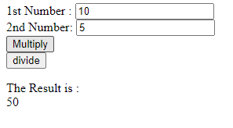 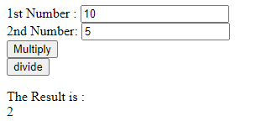

**2.**

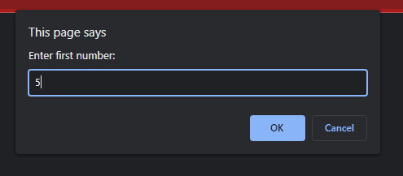 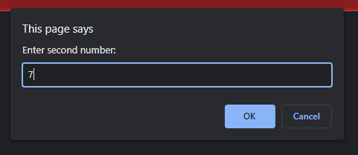

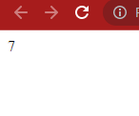

**3.**

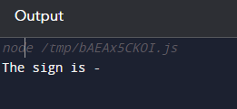

**4.**

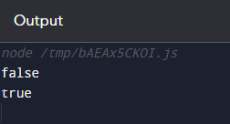

**7.**

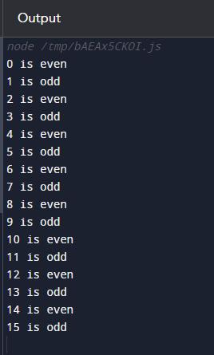

**8.**

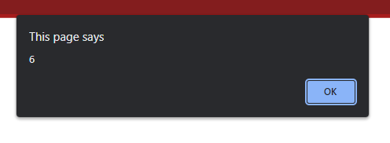

**9.**

